Name__________________________________________
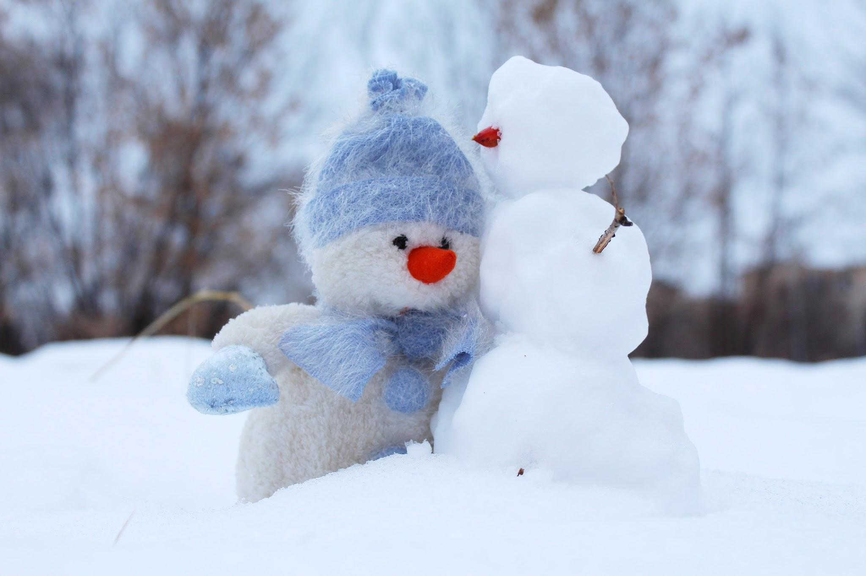
January Homework TIC TAC TOE - Optional
Directions: Choose at least 3 activities on the grid. Everyone must complete the center square. Choose activities that will be fun and challenging for you! When you have completed 3 activities you may decide to be finished OR you can keep going!

- Return this sheet with your first assignment and your selections circled.
- For reference, this will be posted on our blog’s home page.

Math Story  Write your own math story, addition or subtraction. Then solve it, showing your strategies and equation. Be creative and remember to use the mathematical practice of attending to precision. Use attached template. | Space Art  We are studying the stars, sun and moon in science. Create artwork that includes objects in the sky (planets, stars, clouds, etc.) and write a short description. It could be a collage, drawing, painting, etc.--it’s up to you! | New Year’s Resolution  Do you have a goal you want to work on in the new year? It could be something like learning to tie your shoes, read more books or helping your family at home. Write about one resolution or goal that you have, with or without an illustration (template attached or make your own)
Technology  There are many websites with fun craft ideas! With your family’s help, find a website that teaches you how to make a simple craft (examples: paper snowflake or a pinecone bird feeder). Bring your craft in and tell us the steps you used to make it! | ***REQUIRED***  1 lesson/week on  iReady reading/math  (or about 45 minutes). | Timeline  We’ve been learning about time in Number Corner (o’clock, half-past). Create a timeline of your day using these math terms. Include at least 5 events from your day including the time and activity. Be neat and if you like, add an illustration or 2 of your activities.
Research  We’ve learned about birds in science and maps in social studies. Research a bird that migrates, and show on a map (or draw one for an extra challenge!) your bird’s migration route. | Winter Activity Book  Write (and illustrate for an extra challenge!) a book about an activity you and your family like to do in the winter! Use transition words (first, next, then, finally…) and adjectives! | Snowman Math  A group of snowmen want to go to a party, and they do not want to match! They can have a red, orange or yellow hat, and a green, blue or purple scarf. How many different hat/scarf combinations can you colorfully illustrate? Write about how you solved the problem!

